**Requirements for Web app**:

1. Need two functionalities
   1. Email and other written communication
      1. This should be in a doc file. Each new communication should have a unique message no (specific to a customer)
      2. Word doc should be visible and accessible to all users
      3. Admin should have the sole right to delete any document. Other users cannot delete the documents
      4. Document should have following format

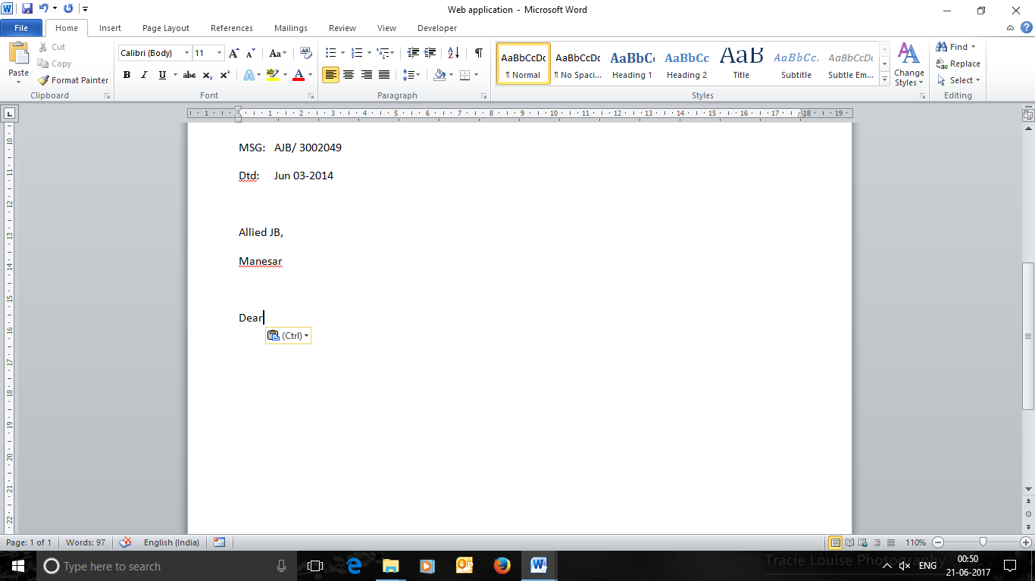

MSG ID – This should be a unique string, first part will be entered manually. Second part will be a five digit auto generated serial number starting from 00001.

Date – Should be the current date

Name of the company should be populated from database.

* 1. Order Generation

We maintain a separate doc file for each principal and append every new order in it.

1. Order generation should have following fields

* Customer: Benara Udyog

This should be a drop down list with single selection populated from db.

* Product: Promaxon D = 1680 kgs

HP 300 = 780 kgs

RB 250 = 1250 kgs

Multiple products can be selected each having different quantity.

* PO Number: Not available yet (Manual)
* Shipment: Jul wk 01/2017 (Manual)
* Payment terms: Net 60 days (Manual)
* Destination: ICD, New Delhi (Manual)

1. Order should be saved in db and appended in the word document for orders
2. The format in which it should be appended in word document is as below

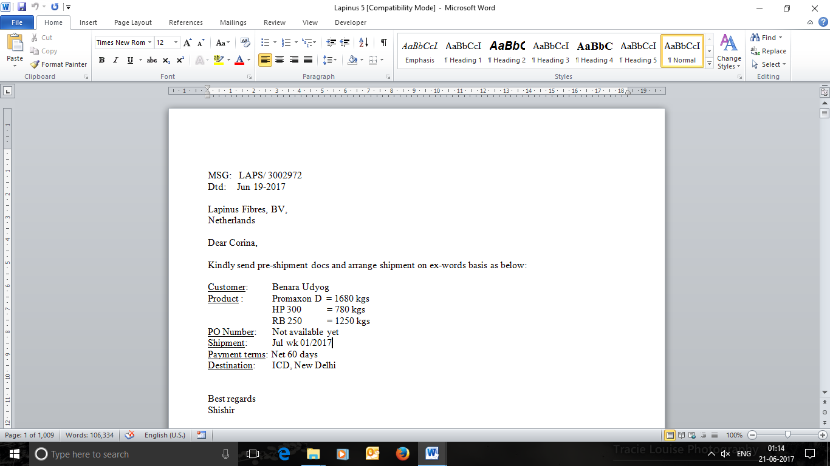

MSG – First part of the string before slash will be manual and second part will be a five digit serial number starting from 00001

Rest all fields should be auto populated from db.

* 1. Admin Role

Web app should have 2 types of login – Admin & User

* + 1. Client Addition
* Name of Company
* Address
* Location
* Contact person – multiple (upto 10 people)

Contact person name

Contact person designation (can be left blank also)

* + 1. Client deletion
    2. Client Updation
    3. Principal Addition
       - Name of Principal
       - Address
       - Location
       - Contact person – multiple (upto 10 people)

Contact person name

Contact person designation (can be left blank also)

* + 1. Principal deletion
    2. Principal details updation
    3. New user creation
* LoginId
* Password
* Email
* Phone number
* Address (optional)
  + 1. User updation and deletion
    2. Order deletion/updation
  1. Report generation
     1. Order history specific to a particular customer
     2. Order history specific to a particular principal
     3. Order history for a particular product
     4. Monthly/quarterly/bi-annually and annual sales report
     5. Sales report for a particular date range
     6. Customer and product mapping
     7. Principal and product mapping
  2. User login

Following tasks are restricted for a user

* + 1. Deletion of any data – order, client, principal and documents
    2. Creation of new user

Note: Pls ensure that we can access the latest version of documents from the server. Since multiple users would be accessing the documents so there should be no conflict.